**JAVA ASSIGNMENT:**

**Q1.)**

import java.util.Scanner;

public class CarCustomizer {

public static void main(String[] args) {

Scanner scanner = new Scanner(System.in);

// Car Manufacturer selection

System.out.println("Select Car Manufacturer:");

System.out.println("1. Mahindra");

System.out.println("2. Tata");

System.out.println("3. Maruti");

int manufacturerChoice = scanner.nextInt();

scanner.nextLine(); // Consume newline

String manufacturer = "";

switch (manufacturerChoice) {

case 1:

manufacturer = "Mahindra";

break;

case 2:

manufacturer = "Tata";

break;

case 3:

manufacturer = "Maruti";

break;

default:

System.out.println("Invalid choice. Exiting.");

return;

}

// Model selection (only for Mahindra)

String model = "";

if (manufacturer.equals("Mahindra")) {

System.out.println("Select Model:");

System.out.println("1. Scorpio");

System.out.println("2. Thar");

System.out.println("3. Scorpio N");

System.out.println("4. XUV 700");

int modelChoice = scanner.nextInt();

scanner.nextLine(); // Consume newline

switch (modelChoice) {

case 1:

model = "Scorpio";

break;

case 2:

model = "Thar";

break;

case 3:

model = "Scorpio N";

break;

case 4:

model = "XUV 700";

break;

default:

System.out.println("Invalid choice. Exiting.");

return;

}

}

// Transmission Variant

System.out.println("Select Transmission Variant:");

System.out.println("1. Manual");

System.out.println("2. Automatic");

int transmissionChoice = scanner.nextInt();

scanner.nextLine(); // Consume newline

String transmission = (transmissionChoice == 1) ? "Manual" : "Automatic";

// Fuel Type

System.out.println("Select Fuel Type:");

System.out.println("1. Diesel");

System.out.println("2. Petrol");

System.out.println("3. CNG");

int fuelChoice = scanner.nextInt();

scanner.nextLine(); // Consume newline

String fuel = "";

switch (fuelChoice) {

case 1:

fuel = "Diesel";

break;

case 2:

fuel = "Petrol";

break;

case 3:

fuel = "CNG";

break;

default:

System.out.println("Invalid choice. Exiting.");

return;

}

// Accessories - Color

System.out.println("Select Color:");

System.out.println("1. Silver");

System.out.println("2. Blue");

System.out.println("3. Yellow");

int colorChoice = scanner.nextInt();

scanner.nextLine(); // Consume newline

String color = "";

switch (colorChoice) {

case 1:

color = "Silver";

break;

case 2:

color = "Blue";

break;

case 3:

color = "Yellow";

break;

default:

System.out.println("Invalid choice. Exiting.");

return;

}

// Location

System.out.println("Select Location:");

System.out.println("1. Delhi");

System.out.println("2. Bangalore");

System.out.println("3. Hyderabad");

System.out.println("4. Chennai");

int locationChoice = scanner.nextInt();

scanner.nextLine(); // Consume newline

String location = "";

switch (locationChoice) {

case 1:

location = "Delhi";

break;

case 2:

location = "Bangalore";

break;

case 3:

location = "Hyderabad";

break;

case 4:

location = "Chennai";

break;

default:

System.out.println("Invalid choice. Exiting.");

return;

}

// Output the selected options

System.out.println("\nYour Car Build Summary:");

System.out.println("Manufacturer: " + manufacturer);

if (manufacturer.equals("Mahindra")) {

System.out.println("Model: " + model);

}

System.out.println("Transmission: " + transmission);

System.out.println("Fuel Type: " + fuel);

System.out.println("Color: " + color);

System.out.println("Location: " + location);

scanner.close();

}

}

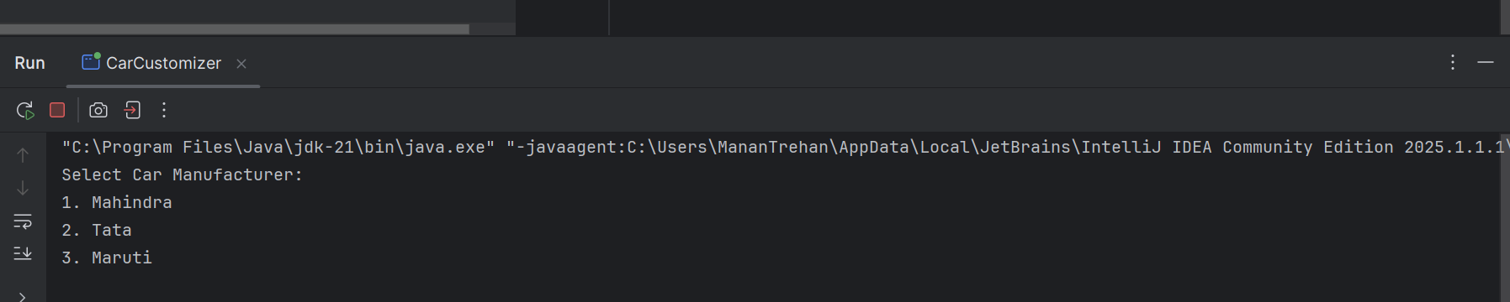

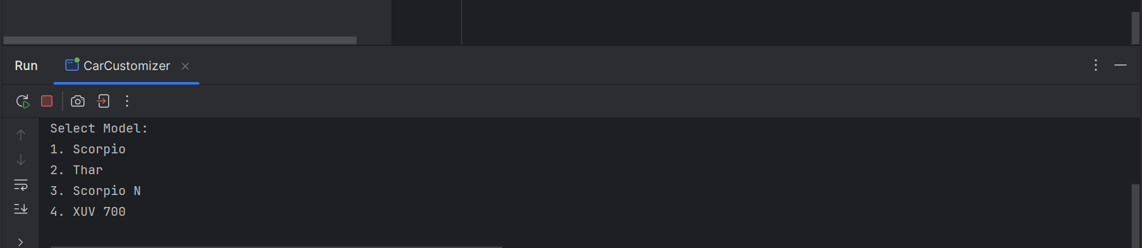

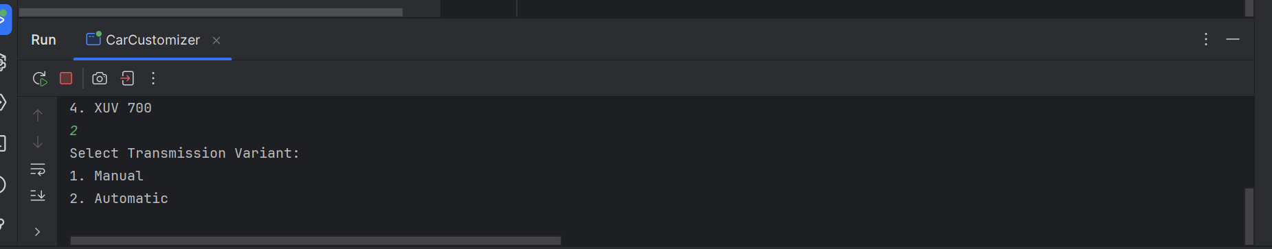

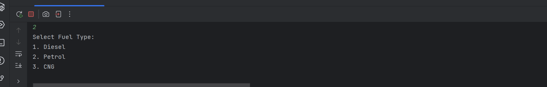

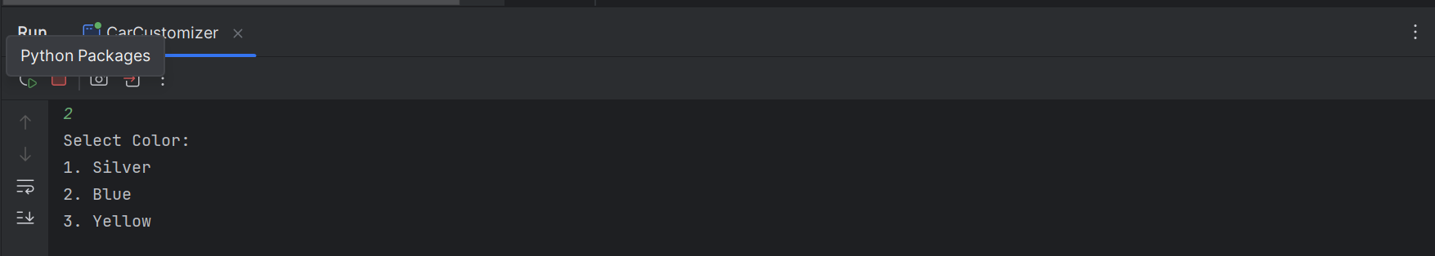

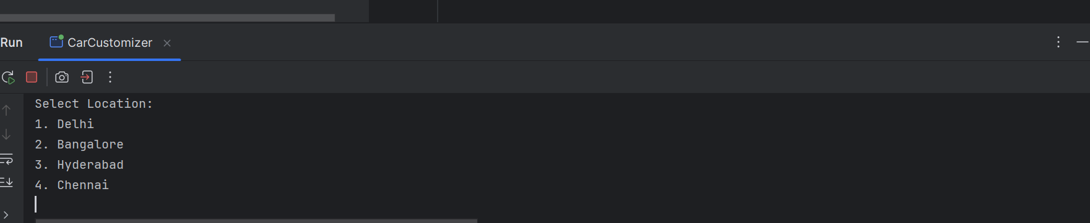

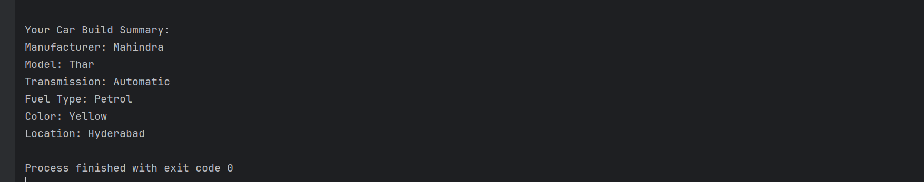

Q2.)

import java.util.Scanner;

public class IncomeTaxCalculator {

public static void main(String[] args) {

Scanner scanner = new Scanner(System.in);

// Input user details

System.out.print("Enter your Annual Salary (INR): ");

double salary = scanner.nextDouble();

System.out.print("Enter your Age: ");

int age = scanner.nextInt();

System.out.print("Investment in Tax-saving Instruments (INR): ");

double investment = scanner.nextDouble();

System.out.print("Health Insurance Premium (INR): ");

double healthInsurance = scanner.nextDouble();

System.out.print("Home Loan Interest (INR): ");

double homeLoanInterest = scanner.nextDouble();

// Apply deductions

double deduction80C = Math.min(investment, 150000);

double deduction80D = age >= 60 ? Math.min(healthInsurance, 50000) : Math.min(healthInsurance, 25000);

double deduction24 = Math.min(homeLoanInterest, 200000);

double totalDeductions = deduction80C + deduction80D + deduction24;

double taxableIncome = salary - totalDeductions;

if (taxableIncome < 0) taxableIncome = 0;

double tax = calculateTax(taxableIncome, age);

System.out.println("\n----- Tax Summary -----");

System.out.printf("Gross Salary: ₹%.2f%n", salary);

System.out.printf("Total Deductions: ₹%.2f%n", totalDeductions);

System.out.printf("Taxable Income: ₹%.2f%n", taxableIncome);

System.out.printf("Total Tax Owed: ₹%.2f%n", tax);

scanner.close();

}

public static double calculateTax(double income, int age) {

double tax = 0;

if (age < 60) {

if (income <= 250000) return 0;

else if (income <= 500000) tax = (income - 250000) * 0.05;

else if (income <= 1000000)

tax = (250000 * 0.05) + (income - 500000) * 0.20;

else

tax = (250000 * 0.05) + (500000 * 0.20) + (income - 1000000) * 0.30;

} else if (age < 80) {

if (income <= 300000) return 0;

else if (income <= 500000) tax = (income - 300000) * 0.05;

else if (income <= 1000000)

tax = (200000 * 0.05) + (income - 500000) * 0.20;

else

tax = (200000 * 0.05) + (500000 * 0.20) + (income - 1000000) * 0.30;

} else {

if (income <= 500000) return 0;

else if (income <= 1000000)

tax = (income - 500000) * 0.20;

else

tax = (500000 * 0.20) + (income - 1000000) * 0.30;

}

return tax;

}

}

